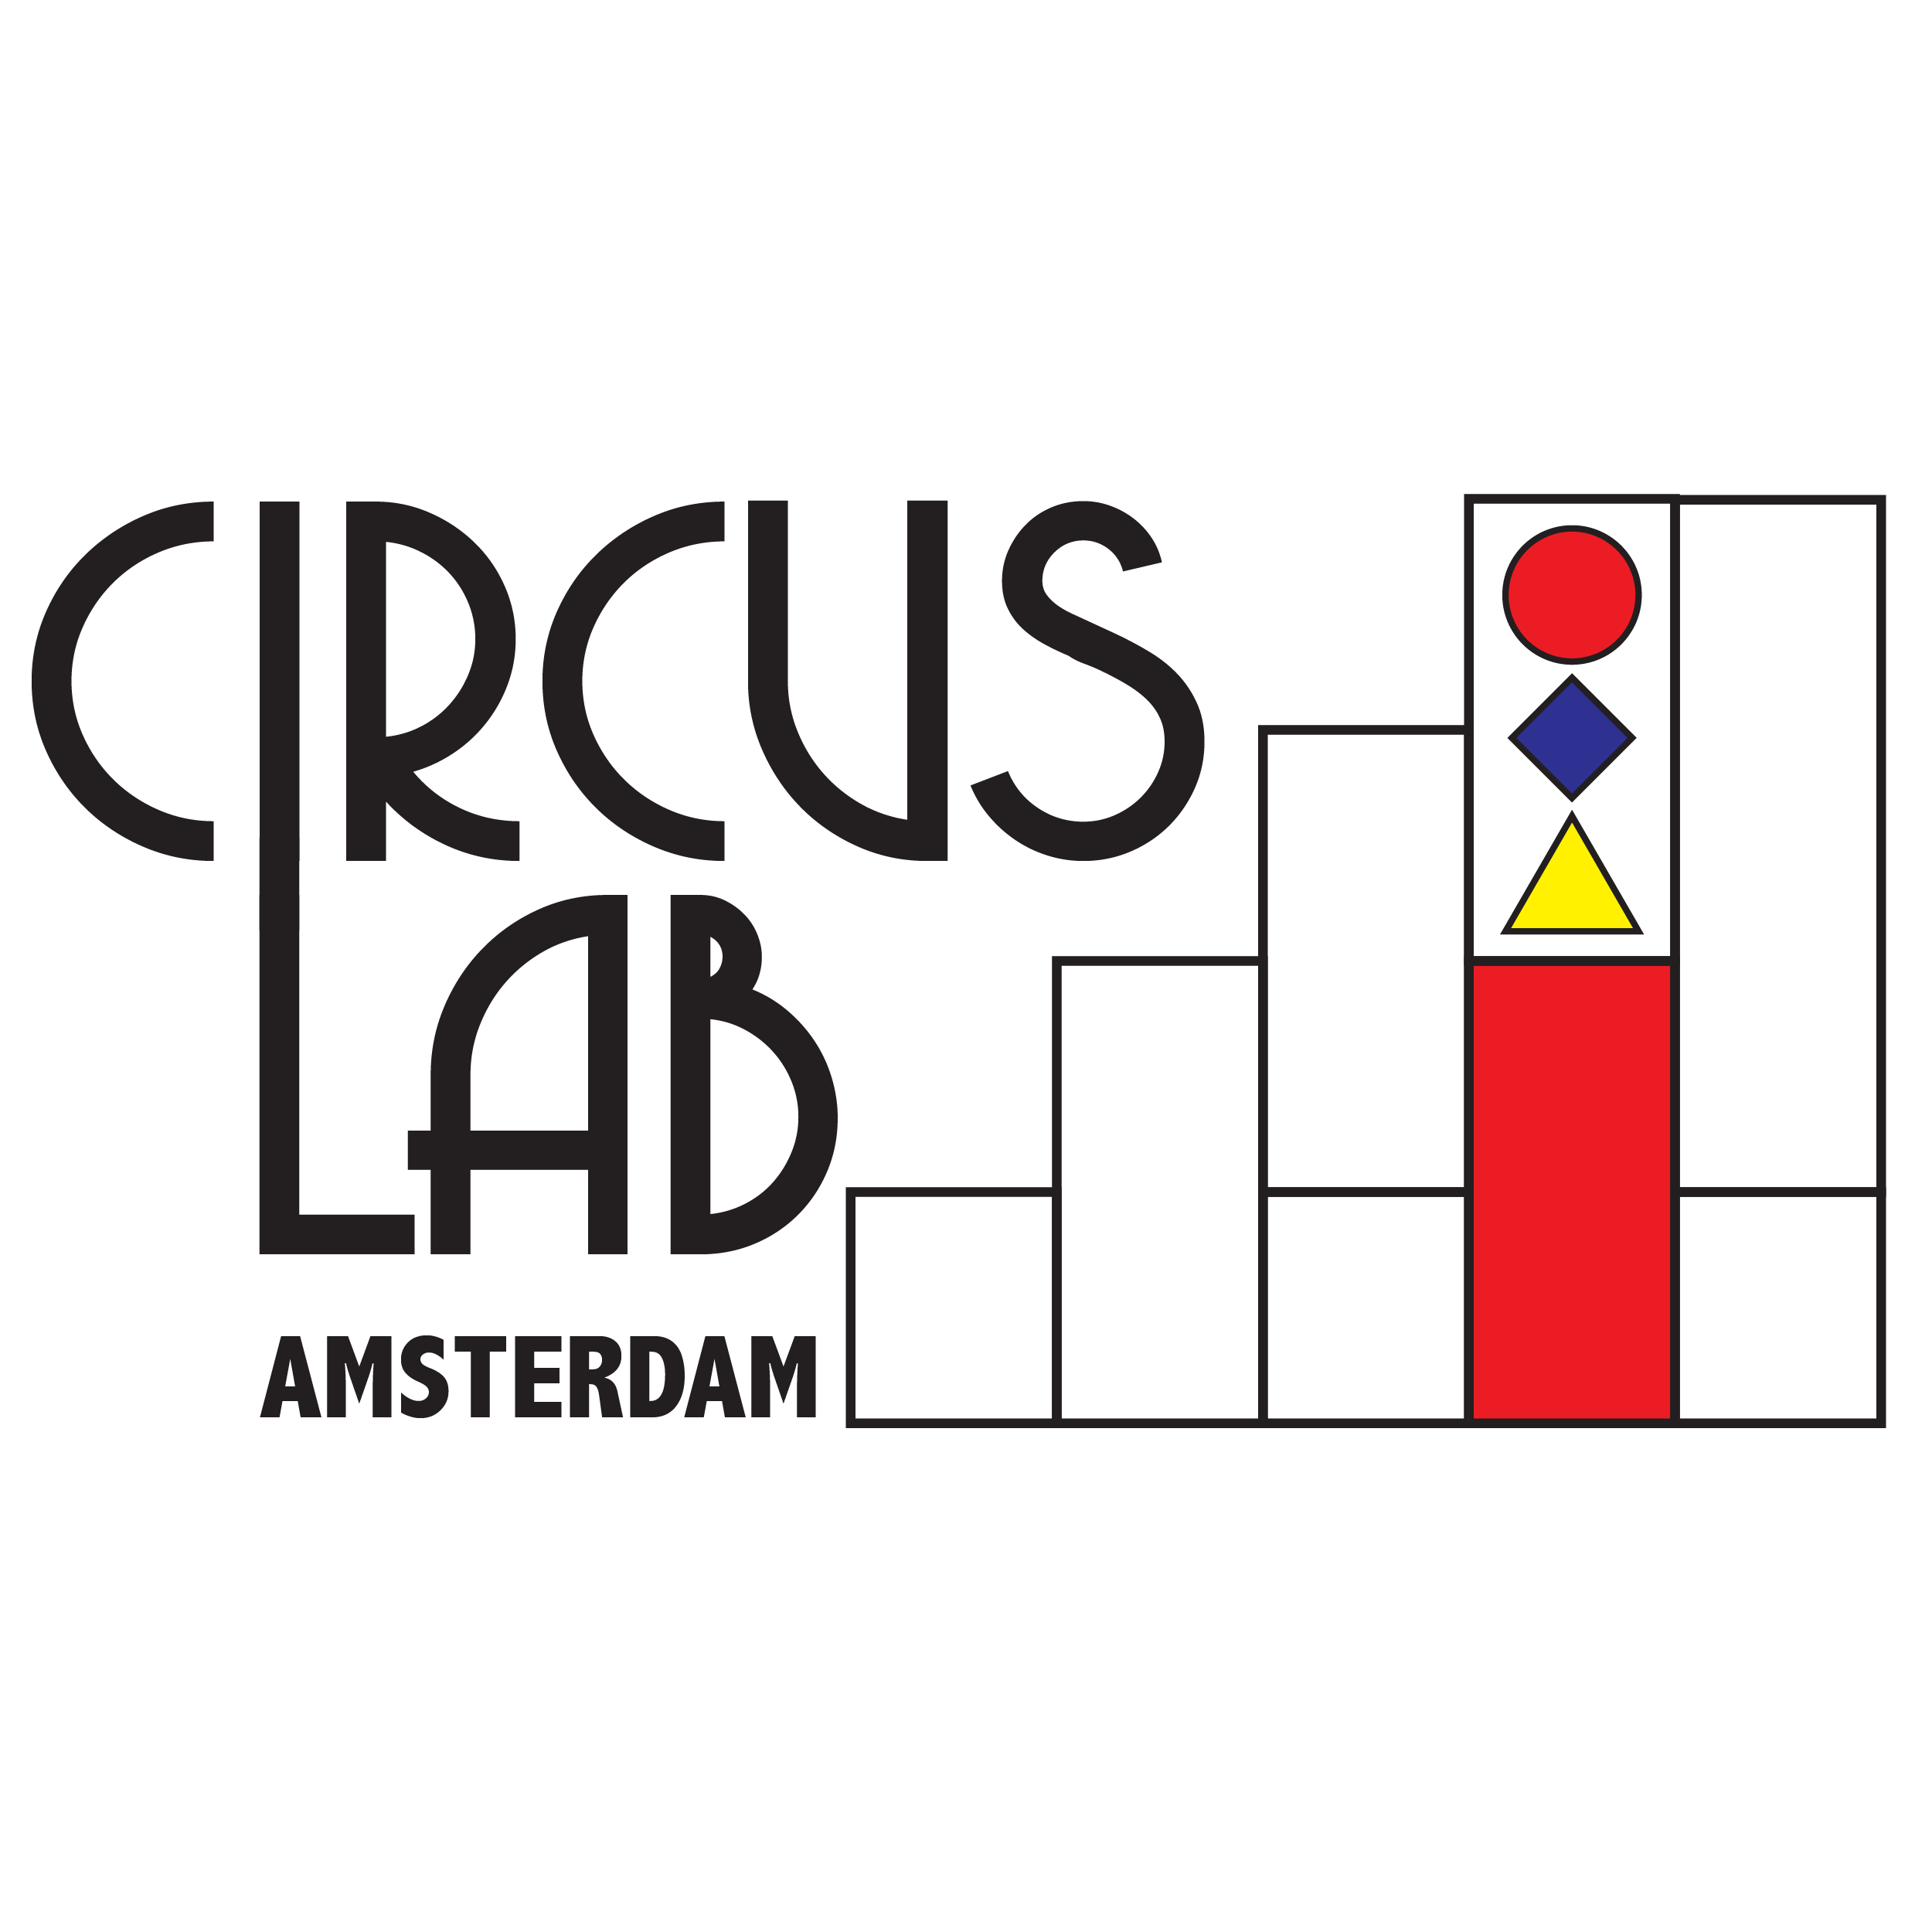
House rules for all users of the CLA studio

Respect and use this studio as if it is your own!

We use a number of rules:

- Use of alcohol is forbidden
- No smoking in the building
- Do not enter the room with outdoor shoes
- Put all materials back where they belong
- The windows must be closed on departure
- The light must be off when you leave
- Eating and drinking is permitted only at the tables in the kitchen
- After using the studio, wipe or vacuum the studio
- After use, wash the cups and kitchen utensils
- Leave the building quietly, without making too much noise

Cleaning items can be found in the bottom cupboards in the kitchen
Vacuum cleaner, broom and dustpan and tin can be found behind the white curtain on the left.

We hope that we can enjoy this great studio together.

Thank you and have fun!

Greetings on behalf of the CLA team

